2 Minute Form
Trip Name: Matheson’s Bay to Goat Island
Check-in Name and Phone:
Date: Branch:
Leaders
Cell Phone Number
VHF Call Sign &/or Vessel Name
Vehicle make, model, registration, colour
General Plan
Note: If plan changes, you must notify your Check-in person.
Latest Time Off the Water |  |  |  |  | TMP/ AMP used²⁰
Tide/ Forecast Lake Level | Low |  |  | High | Other
Communications Carried²¹
Communications | We will be communicating as a group on VHF Channel _____
Equipment Carried
Trip Report
(Use other side if more space required)

Activity | Club trip | Centre | Auckland | Location |  |  |  |  | Difficulty¹ |  |  | Intermediate plus
Activity Description | Meet at Matheson’s Bay. Getting there – head north, through Matakana, past the turnoff to Omaha, don’t go down Matheson’s Bay Road, but just past there turn right half way up the hill, go down Grand View Road and follow it down to the beach. Paddle north along the coast, around Cape Rodney to Leigh and Goat Island. |  |  |  | Leader qualification req.² |  | Leader
Get in Location | Matheson’s Bay |  |  |  | Chart/ Map no.⁴ |  | 532 |  | Distance |  |  | Approx. 15km
Get out Location | Matheson’s Bay |  |  |  | Coastguard Channel |  | 82 & 16 |  | Nowcasting |  |  | 21
Emergency get out ⁵ | There are a couple of beaches along the way. |  |  |  | Emergency / Coastguard Station |  | Auckland |  | Phone |  |  | *500  09 303 4303
 |  |  |  |  | Drinking Water⁶ | ? |  | Toilets⁷ |  |  | Matheson’s Bay & Leigh
Emergency Response | Refer Emergency Response Booklet |  |  |  |  |  |  | Parking⁸ |  |  | Matheson’s Bay & Leigh
Specific Equipment Required⁹ | Helmet if rock gardening. Wetsuit, mask, snorkel, fins if you wish to see the fishies. |  |  |  | Working Communications equipment in this area¹⁰ | Cell phone  Sat phone |  |  |  | Mountain Radio |  |  | PLB  VHF
Other resources  and notes¹¹ | Goat island is one of the best trips in the region. This area is a renowned marine reserve with a huge number and variety of aquatic life. Go around Goat Island where there are caves to explore.  This is a marine reserve, no fishing. |  |  |  | Weather Parameters¹² | Beginners Wind under 15 knots, no significant surf or swell  Intermediate Wind under 25 knots, and surf or swell less than 1.5 metres  Advanced Any condition that is suitable for the trip's aims
Previous incidents¹³

Safety Management¹⁴
Hazard |  | Significant? |  | Management Strategy¹⁵ |  |  |  | Hazard | Significant? | Management Strategy¹⁵
Cold Water |  | Yes |  | Carry spare dry clothes and shelter |  |  |  | Deep Water | Yes | Correctly fit PFDs
Medical Conditions |  | Yes |  | - Leader has first aid qualification  - Ask customers about medical conditions |  |  |  | Bad Weather | Yes | Understand weather forecasts.  Have back up plans or pull out if necessary
Capsizing |  | Yes |  | - Correctly fit PFDs  - Skills at performing rescues. |  |  |  | Heat / Sun | Yes | - Protective Clothing (worn)  - Sun Screen  - Plenty of drinks  - Sunglasses
Panic |  | Yes |  | Ensure conditions match level  of skills |  |  |  | Obstacles | Ye s | Awareness of reefs, navigational hazards, nets
Rock gardening/caves |  | Yes |  | Plenty of interesting rock gardening, but take care if there is any swell. Wear helmets if getting in amongst it and ensure participants have the necessary skills. |  |  |  | Other Vessels | Yes | - Understand the “rules of the sea”  - “Be seen” – Have two of the following; flag, brightly coloured kayak, brightly coloured Pfd or hat. At night: an all round white light & a powerful torch.
Swell |  | Yes |  | Even on calm days this part of the coast is exposed to ocean swell which can be significant, particularly as you round Cape Rodney. Ensure participants have the skills to deal with this.
Written up by: | Larraine Williams |  | Approved By: |  | Russell Williams | Signed: | RW |  | Date: | 13 Mar 14 | Review in: | 12 months from date of approval

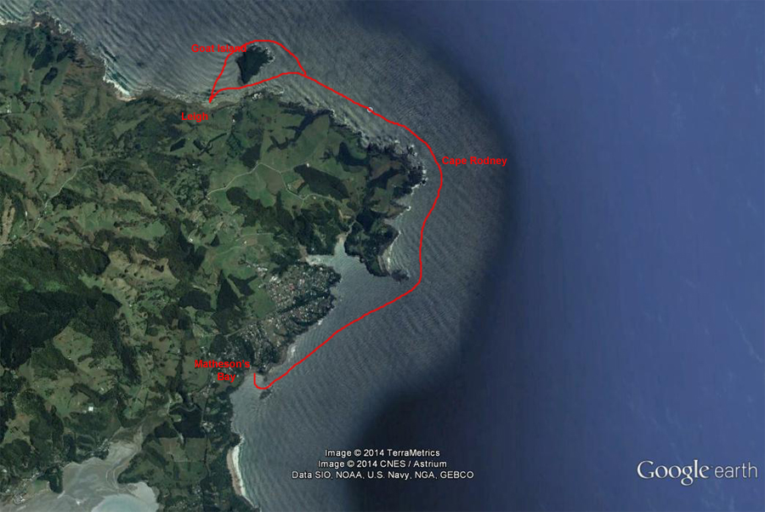
Additional Information Sheet (Optional)
Introduction (A general introduction)
Description (A description of the tour – as if you were selling the idea to someone)
Local Attractions |  | Transport/ Local Operators
 | Contact details |  | Contact details
Local Eateries
 | Contact details
Accommodation/ Campsite Locations |  |  | Facilities
Name |  |  | Cabins |  | Fuel
Phone |  |  | Showers |  | Power
E-mail |  |  | Toilets |  | Water Access
Website |  |  | Laundry |  | Pool
Physical Address |  |  | Water |  | Fires Allowed
Other |  |  | Supplies
Other information

